RRID TO DO LIST 8/9/19

1. Home page - Top Nav - Image of Watch ID needs to be changes to one of my Watch ID images. Copyright problem!

*We have changed watch id image – You can check steps in video.*

1. Remove hyperlink to Bands under Accessories, but leave “Bands” there. Those images are also a copyright problem. I’ll work on replacements.

*Hyperlinks are removed. You can change images its also illustrated in video. By clicking on Menu Items in CMS Tab*

1. Replacement Tags -- you only have three listed -- there should be four.

*All four are listed you can check video for reference*

1. Replacement Tags -- the Sprint tag (small one) is not my image - please replace.

*By following steps in video you can change image.*

*Step # 01: Click on Items in Catalog Tab and then search for relevant product*

*Step # 02: Edit the sprint tag item and change its image*

1. The first two replacement ID tags are not my images, please replace with the images I provided.

*By following steps in video you can change image.*

*Step # 01: Click on Items in Catalog Tab and then search for relevant product*

*Step # 02: Edit the sprint tag item and change its image*

1. Read More icon on Home page links to Holders - maybe a better place to read more is Blog article #1.

*This link is editable. Check video for reference.*

1. Home Page - yellow section. Images are distorted - can you remove this section? Or replace images with those found in red and black squares? Or fix distortion?
2. Home Page - Find Your Perfect ID - images not lined up black and red squares.

??

1. Remove Black ID tag and clasp option - I don’t sell that color.

*It’s done*

1. Main Category images under sun towards bottom of Home page need to be replaced with images I sent - there’s a typo in the images you have up there now.

??

1. Remove Event Sponsorship link in Footer Navigation.

*Removed*

1. Remove current blog content and add the blog content from current Road Runner ID blog. Add image: (see attached)

*Done*

1. Sprint ID:
   1. Add sizes - Large, Med, Small, X Small
   2. Remove Yellow option
   3. Remove Royal Blue option
   4. Add Orange image (Take Images from Usman)
2. Pro - Thin
   1. Remove Green option
   2. Most of the images are of the Pro model (Pink, Red, Blue, Purple) - please add the Pro -Thin images supplied.
3. Endurance ID
   1. Add sizes - Large, Medium and Small
4. Pro ID
   1. Remove Green option
   2. Yellow picture is wrong (copyright) - add my Yellow image.
5. Dog Tag images are not mine, replace with images supplied.
   1. Add **Dark Green** option
   2. Same for customizing page - not my images.
6. Shipping on Custom pages - should read: “Ships within 24 hours, weekends the following Monday”. 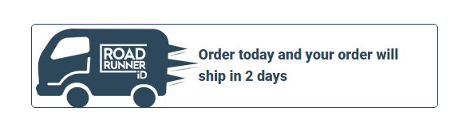
7. Watch ID - offer only Large on its custom page and the same for Small.
8. Change Top Navigation - “Clearance” to “Apparel” and related page.